PART A --- (10 x 2 = 20 marks)

1. The eigenvalues and the corresponding eigenvectors of a 2 x 2 matrix is given by λ₁= 8; x = and λ₂= 4; x₂ = . Find the corresponding matrix.

2. Determine the nature, index and signature of the quadratic form x₁²+5x₂² + x²₃ + 2 x₂ x₃ + 6x₃ x₁ + 2x₁ x₂.

3. For what values of the constant c is the function f continuous on (-∞, ∞)?

4. Find the slope of the circle x² + y² = 25 at (3,-4).

5. Find , if .

6. Find and in terms of r and s if w= x²+ y², x = r-s and y = r+s.

7. Evaluate

8. Find the area of the region shown in the diagram given below, bounded between x = a and x = b.
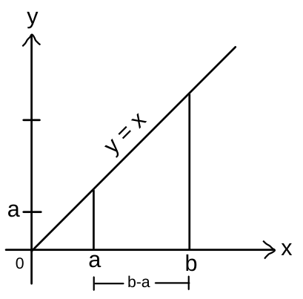

9. Sketch the region of integration in

10. Change the Cartesian integral into an equivalent polar integral.

----------------------------------------------------------------------
PART B --- (5x16= 80 marks)

11. (a) Obtain an orthogonal transformation which will transform the quadratic form Q = 2x₂x₃ + 2x₃x₁ + 2x₁x₂ to canonical form.

(Or)

(b) An elastic membrane in the -plane with boundary circle x₁² + x₂² = 1 is stretched so that a point P = (x₁, x₂) goes over a point Q = (y₁, y₂) given by y₁ = 5x₁ + 3x₂ and y₂ = 3x₁ + 5x₂ . Find the principal directions that is, the directions of the position vector x of P for which the direction of the position vector y of Q is the same or exactly opposite. What shape does the boundary circle take under this deformation?

12. (a) (i) Find y^{n} if x⁴ + y⁴ = 16.

(ii) Differentiate .

(Or)

(b) Find the intervals on which is increasing and decreasing. Where does the function assume extreme values? What are those values?

11. (a) Find the maximum and minimum values of the function f(x, y) = 3x + 4y on the circle x²+ y² 1.

(Or)

(b) Find the Taylor series expansion of the function f(x,y) = sin x sin y near the origin.

14. (a) (i) Evaluate for a >0.

(ii) Integrate .

(Or)

(b) (i) Evaluate

(ii) Integrate

15. (a) (i) Change the order of integration in and hence evaluate.

(ii) Find the area of the region inside the cardioid r = a (1+cosθ) and outside the circle r = a.

(Or)

(b) Find the volume of the region bounded by the paraboloid and z = x² + y² the plane and z = 4.

